LCBC – Lorain County Bicycle Club 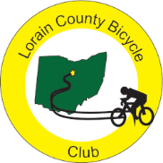
December 2023 Newsletter

Welcome to the cold season! Luckily the Red Flannel weather was much nicer. Once again,
Special thanks go to Karen who did an outstanding job of overseeing this year’s Red Flannel. She writes “A big Thank You to all the club members that were able to paint the routes, make chili, bake cookies and pitch in November 5th.
I especially want to thank those that took a lead at the ride start and rest stops; Louise, Nancy and Karla. Thanks to Ron C for stepping in as SAG coordinator in Clyde's absence. In all we had 220 riders despite the very foggy start to the day.
There were lots of happy riders; riders who gobbled up the soups, drank cider, hot or cold and announced that the cookie variety was the best. At the end of the day we only had one SAG pickup”.

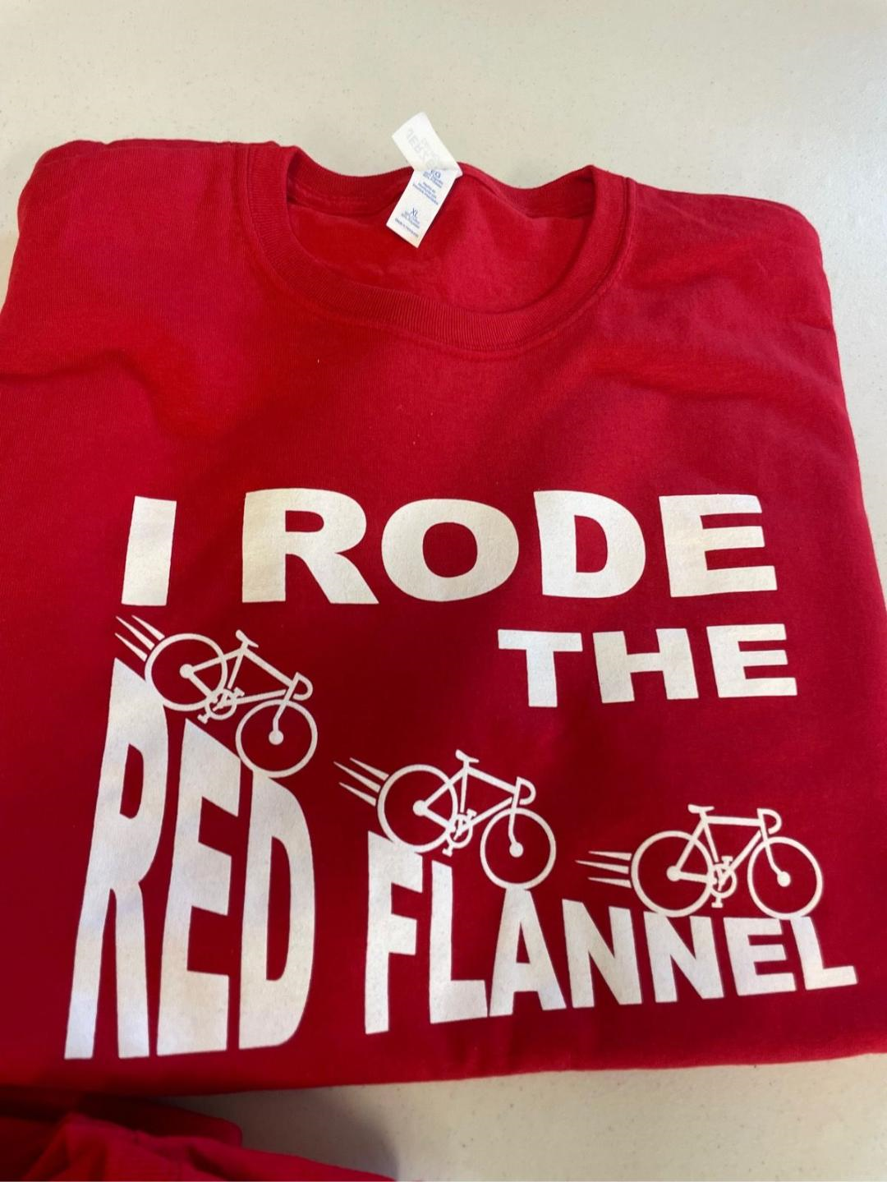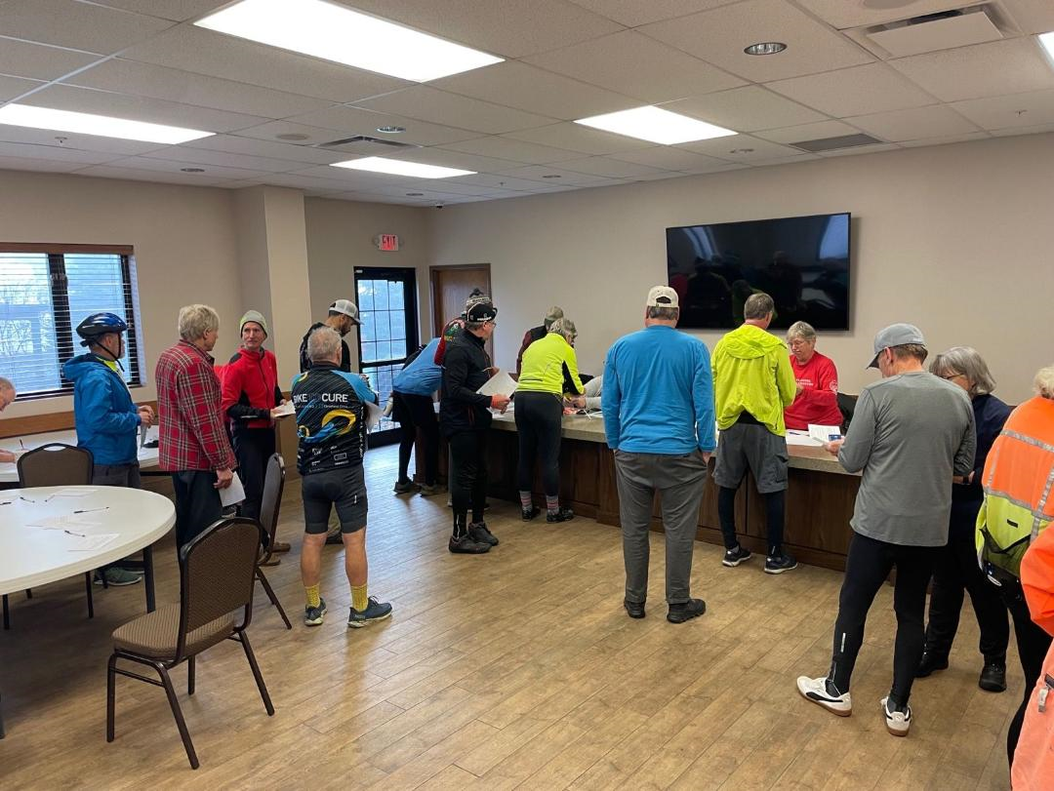

Here are some pictures from the Red Flannel
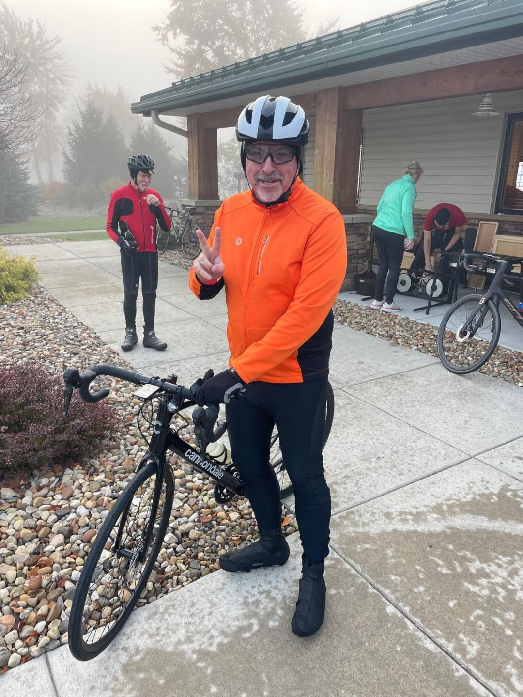
Foggy Start for the ride
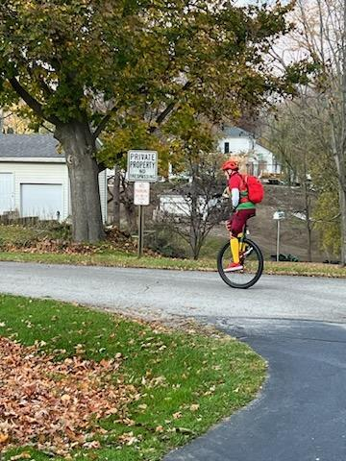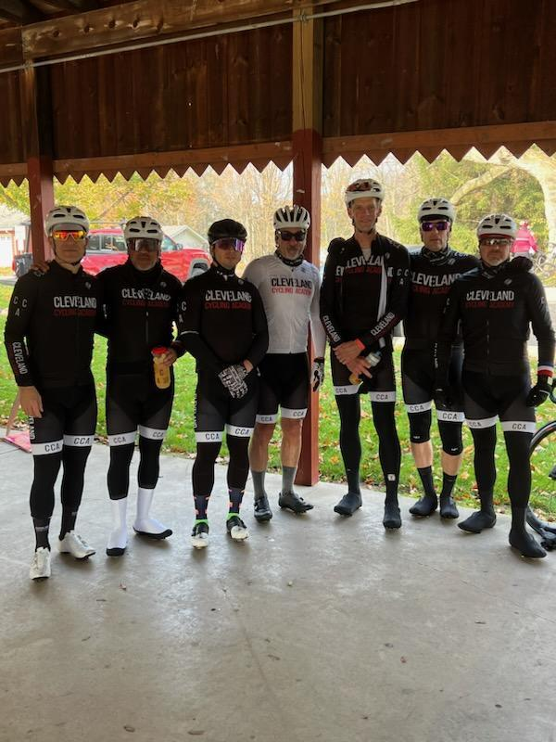
Unicyclist coming into Milan and members of the Cleveland Cycling Academy at Milan

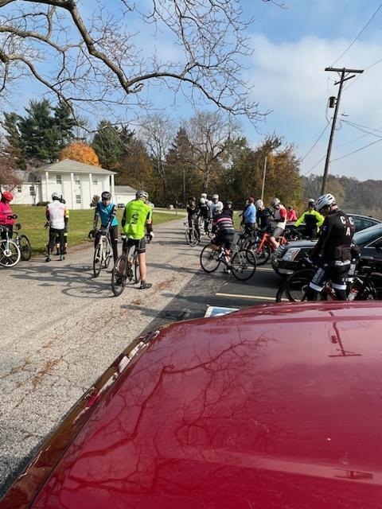
Coming and going from Milan

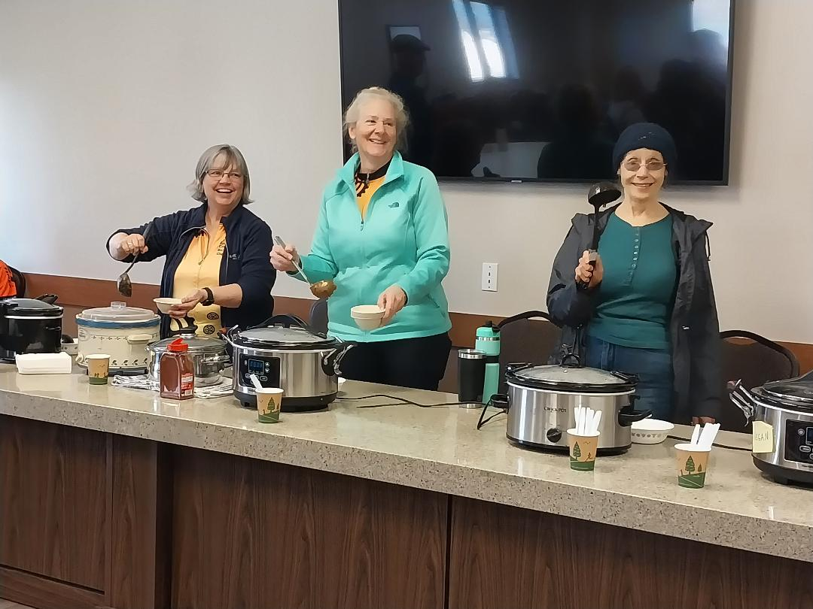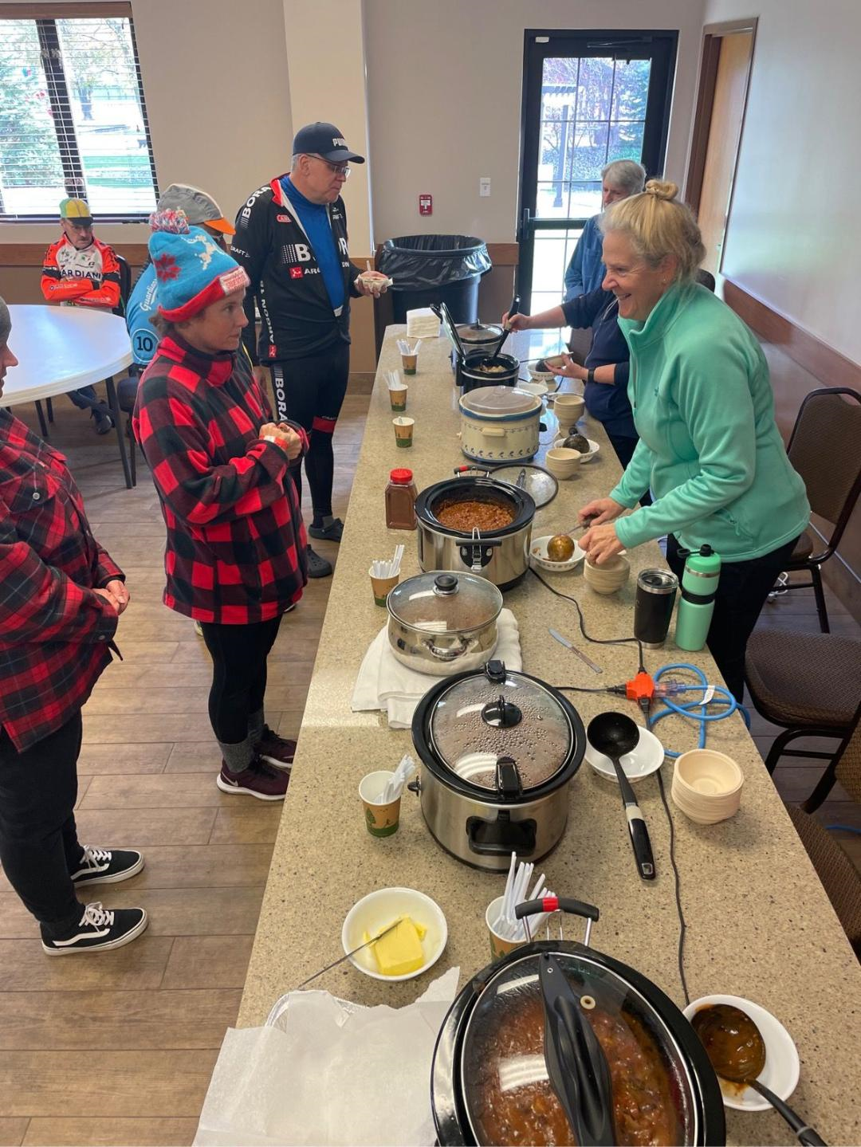
Indoor serving at the New Russia Township Hall
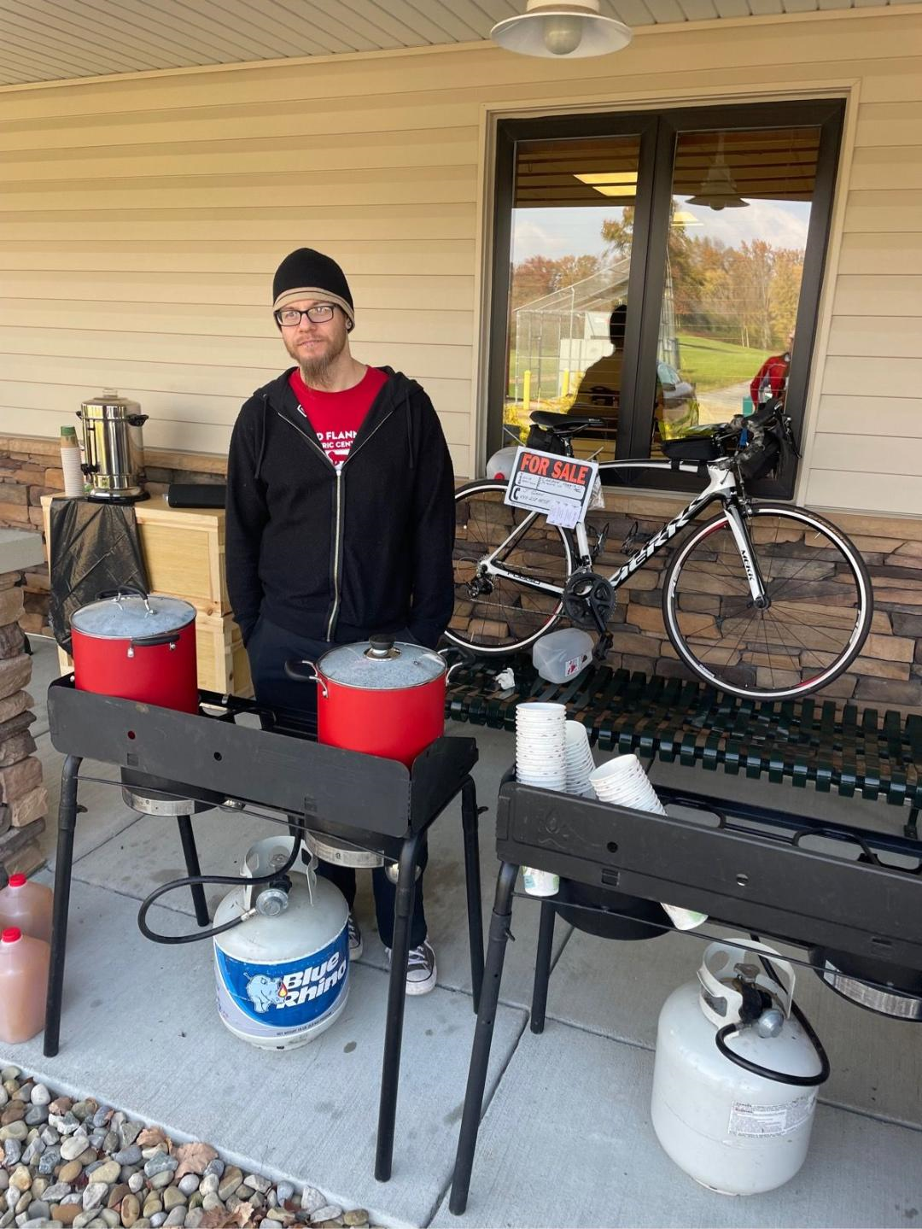
Outdoor chili and beverages at New Russia Township Hall

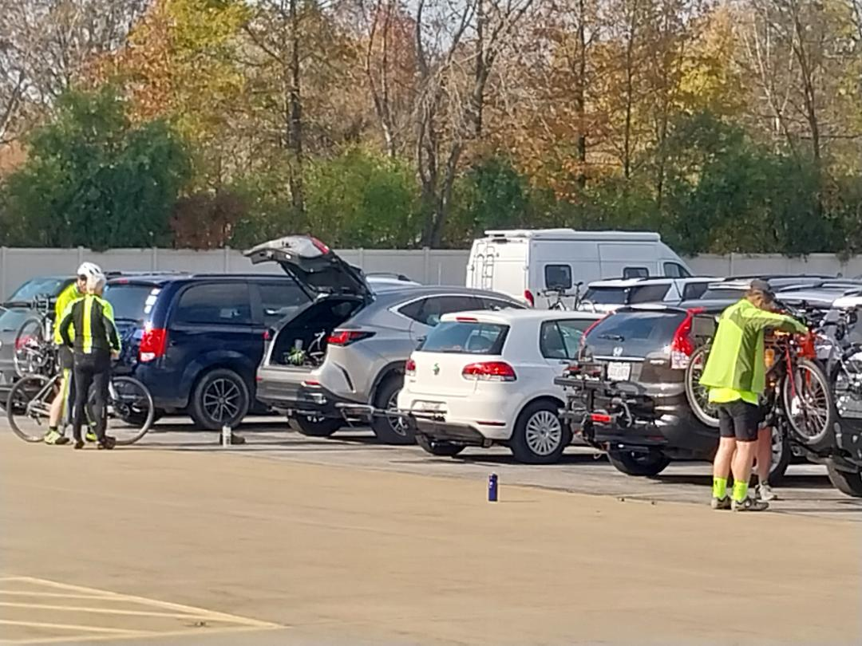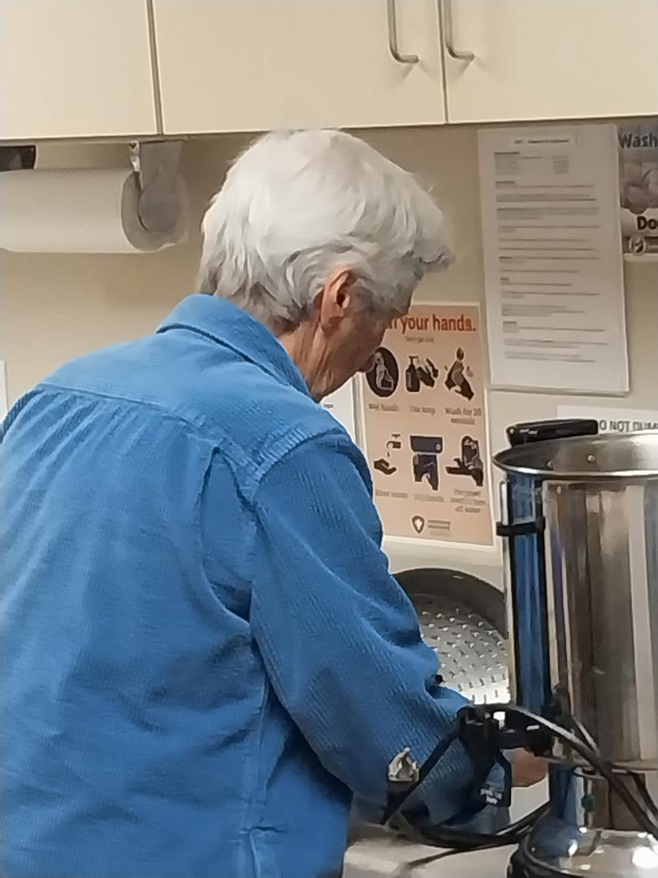
Cleaning Up while riders load up their bikes after a great day of riding and eating

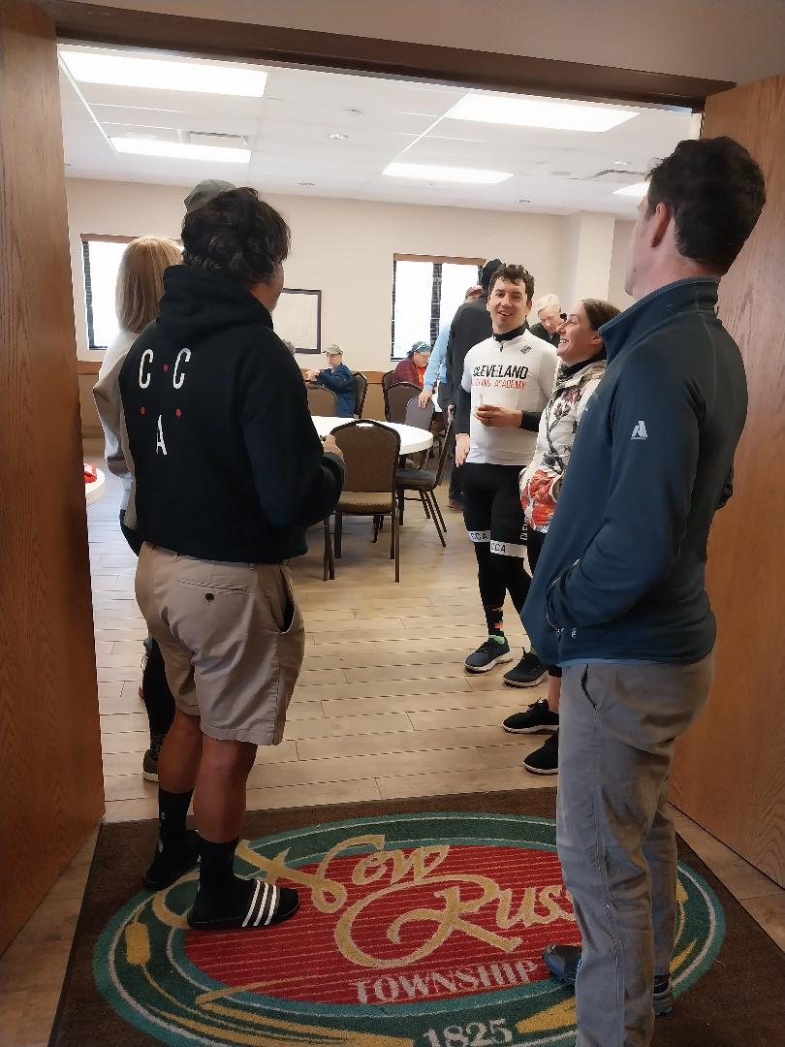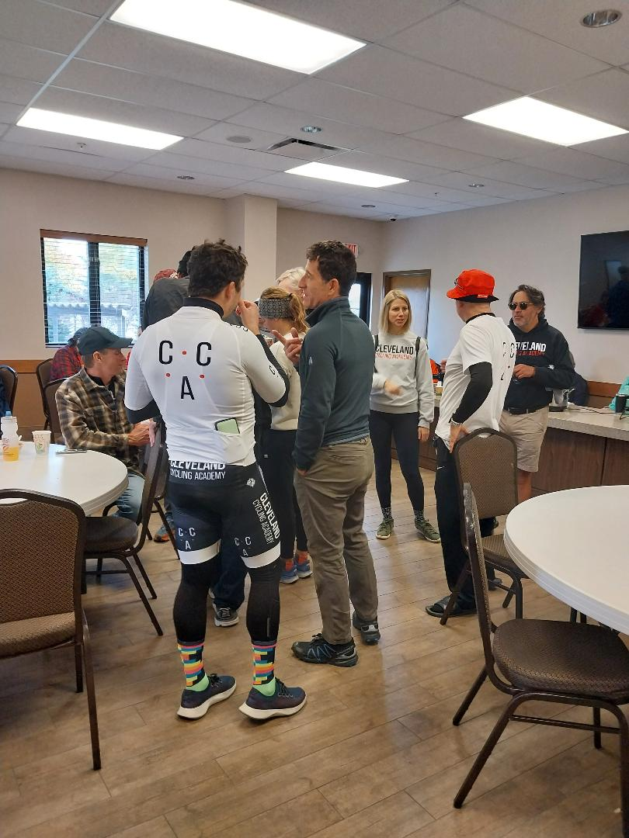
Getting some chili, cookies, and drinks before heading home
Pictures thanks to Ralph, Shane, and Bill.

President’s corner

Thanks to the whole club for coming together for another successful Red Flannel ride. With January just around the corner, we need to figure out who will lead the RF next year since Karen cannot do it. Being the RF coordinator is also the vice president of the club. If there are no volunteers stepping forward in the next month, I would be willing to do it. However, I would then step down from my other two posts (president and secretary). So we would need a volunteer to take up each of those roles. C’mon folks, running a club does take a little labor from its members. Thanks for thinking about how you can be involved.
Karla

Editor’s note: As you read in Karla’s “President’s Corner” post, we will need some new leadership for the club. We know Karla will still be involved but there will be at least one or two leadership openings. The elected (frequently volunteered for) positions are President, Vice President/Red Flannel Coordinator, Secretary, Treasurer, Ride Captain, Web Manager, and Newsletter Publisher. As you consider how you might help the club, keep in mind that when you are in a leadership position, you get to know fellow members beyond the seat of a bike. If you are interested in (willing) to assume any of these positions let any one of the officers know,

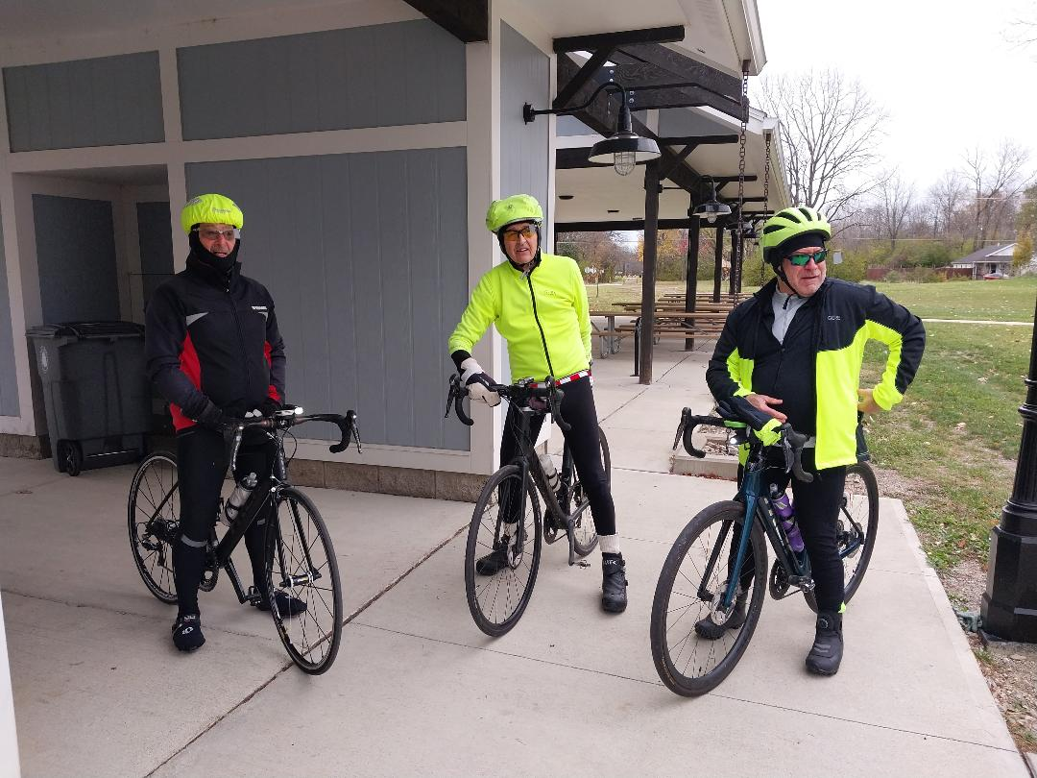
Club stalwarts on a cold November weekend ride

Remember that December is the last month to log miles for the year. If you are shy of your goal, bundle up and join the stalwarts in riding this month.

Lorain County Bicycle Club

 | December 2023
Sun | Mon | Tue | Wed | Thu | Fri | Sat
26 | 27 | 28 | 29 | 30 | December 1 | 2
9 am  U-show 32 miles. Start at Oberlin Gasholder Building, 291 South Main Street, Oberlin, OH 44074 |  | 11 am  30 miles. Start at Oberlin Gasholder Building, 291 South Main Street, Oberlin, OH 44074 |  | 11 am  30 miles. Start at Oberlin Gasholder Building, 291 South Main Street, Oberlin, OH 44074 |  | 9 am  U-show 32 miles. Start at Oberlin Gasholder Building, 291 South Main Street, Oberlin, OH 44074
3 | 4 | 5 | 6 | 7 | 8 | 9
9 am  U-show 32 miles. Start at Oberlin Gasholder Building, 291 South Main Street, Oberlin, OH 44074 |  | 11 am  30 miles. Start at Oberlin Gasholder Building, 291 South Main Street, Oberlin, OH 44074 |  | 11 am  30 miles. Start at Oberlin Gasholder Building, 291 South Main Street, Oberlin, OH 44074 |  | 9 am  U-show 32 miles. Start at Oberlin Gasholder Building, 291 South Main Street, Oberlin, OH 44074
10 | 11 | 12 | 13 | 14 | 15 | 16
9 am  U-show 32 miles. Start at Oberlin Gasholder Building, 291 South Main Street, Oberlin, OH 44074 |  | 11 am  30 miles. Start at Oberlin Gasholder Building, 291 South Main Street, Oberlin, OH 44074 |  | 11 am  30 miles. Start at Oberlin Gasholder Building, 291 South Main Street, Oberlin, OH 44074 |  | 9 am  U-show 32 miles. Start at Oberlin Gasholder Building, 291 South Main Street, Oberlin, OH 44074
17 | 18 | 19 | 20 | 21 | 22 | 23
9 am  U-show 32 miles. Start at Oberlin Gasholder Building, 291 South Main Street, Oberlin, OH 44074 |  | 11 am  30 miles. Start at Oberlin Gasholder Building, 291 South Main Street, Oberlin, OH 44074 |  | 11 am  30 miles. Start at Oberlin Gasholder Building, 291 South Main Street, Oberlin, OH 44074 |  | 9 am  U-show 32 miles. Start at Oberlin Gasholder Building, 291 South Main Street, Oberlin, OH 44074
24 | 25  Christmas Day | 26 | 27 | 28 | 29 | 30
9 am  U-show 32 miles. Start at Oberlin Gasholder Building, 291 South Main Street, Oberlin, OH 44074 |  | 11 am  30 miles. Start at Oberlin Gasholder Building, 291 South Main Street, Oberlin, OH 44074 |  | 11 am  30 miles. Start at Oberlin Gasholder Building, 291 South Main Street, Oberlin, OH 44074 |  | 9 am  U-show 32 miles. Start at Oberlin Gasholder Building, 291 South Main Street, Oberlin, OH 44074
31 | January 1  New Year's Day | 2 | 3 | 4 | 5 | 6
9 am  U-show 32 miles. Start at Oberlin Gasholder Building, 291 South Main Street, Oberlin, OH 44074 |  | 11 am  30 miles. Start at Oberlin Gasholder Building, 291 South Main Street, Oberlin, OH 44074 |  | 11 am  30 miles. Start at Oberlin Gasholder Building, 291 South Main Street, Oberlin, OH 44074 |  | 9 am  U-show 32 miles. Start at Oberlin Gasholder Building, 291 South Main Street, Oberlin, OH 44074

