LCBC – Lorain County Bicycle Club 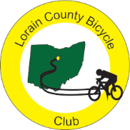
September 2023 Newsletter

August was another good cycling month.”Roast Your Buns” ride was held on the first Sunday of the month and there was a good turnout of club and non-club riders. Half of the riders did the 52 mile route and the others did the full 73 miles. There were a few sprinkles on the southern part of the ride but nothing that stopped the riders.
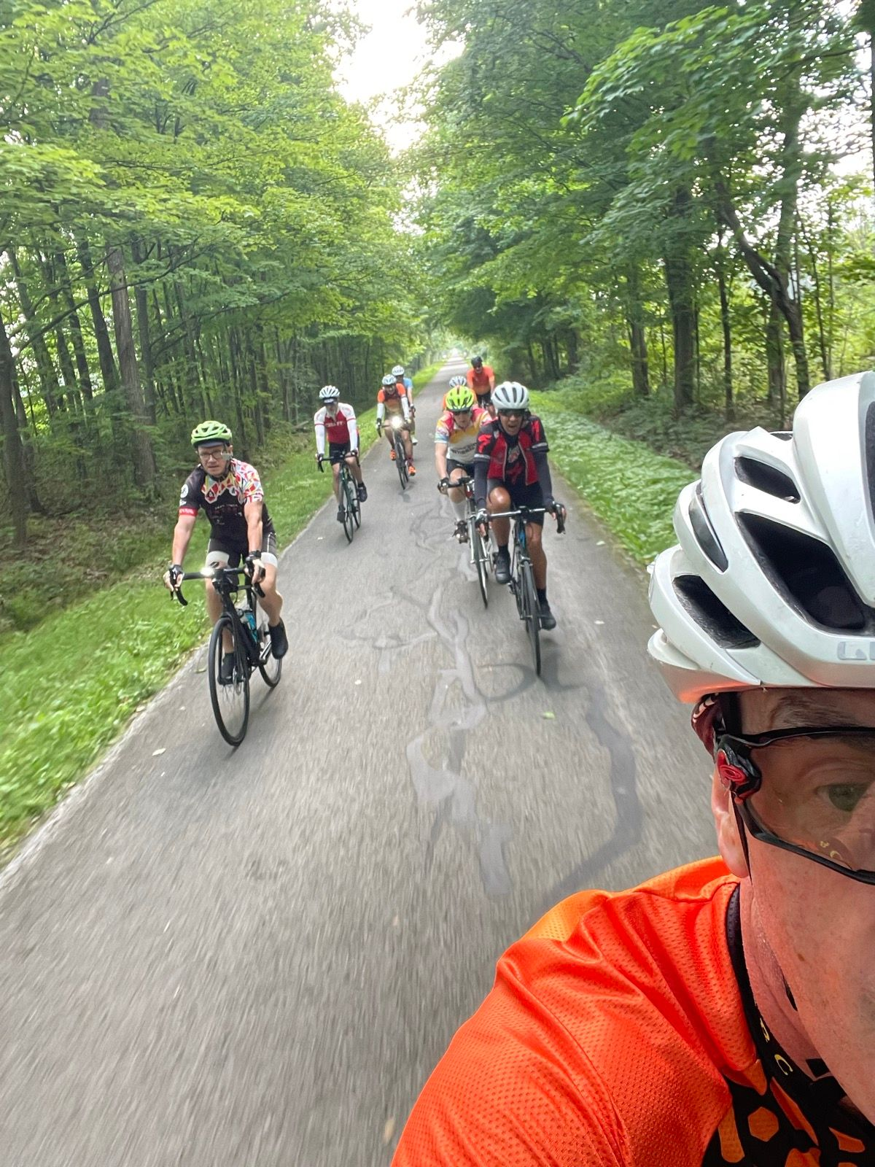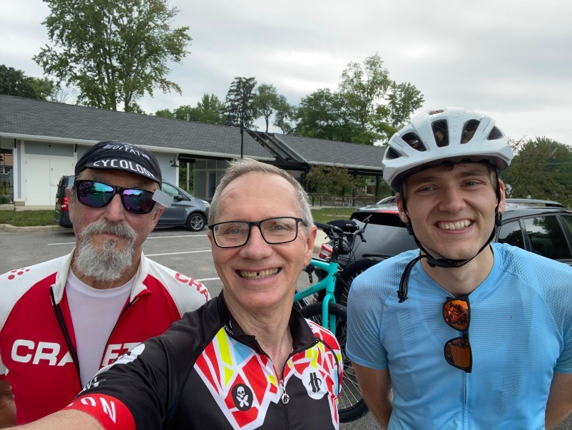
Roast Your Buns heading out on the trail Three of the non-club riders including former member Barron

August also marked the return of David and the loss of Terry who had shoulder surgery. Paul has been in Florida with his mom and Shane has been doing a lot of travelling. Overall, the club has had fairly good turnout for their rides. There was even on ride with an alternate start point with a route to West Salem. A ride to Huron was well attended as were several weekday rides. The month of August ends with a full-blue-super moon which should be a good omen for September.
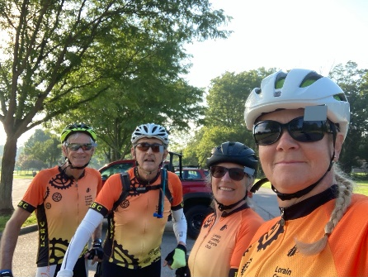 West Salem Ride

If you wake up some morning and ask yourself “why ride with the club,” here are two reasons.
- 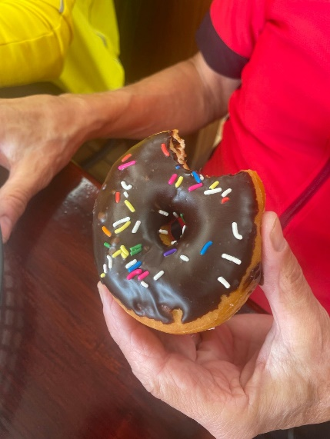 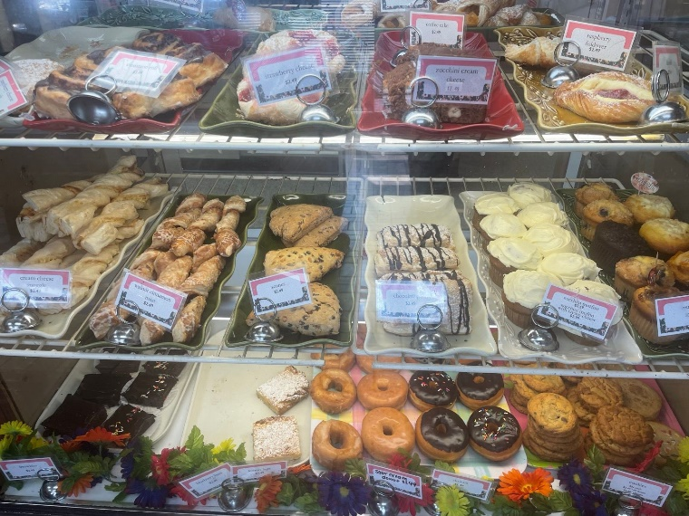 You can enjoy pastries and conversations with friends.
- 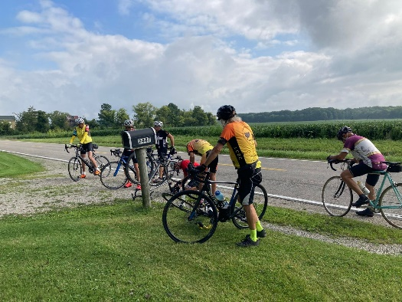 If you have a flat, you can get free advice and comments from your fellow riders. On occasion someone may also lend a hand.

RED FLANNEL UPDATE
Karen submitted a RED FLANNEL reminder.
RED FLANNEL - November 5, 2023
(In just 9 weeks)

Flyers Printed and being distributed to bike shops. Please take flyers to your favorite fall rides. Just let me know and I will get you the Red Flannel Flyers.
Route – using our proven routes, 62 miles, 31 miles and 26 flat land trail miles.

Time to gather up LCBC members, all members help to support this are only fundraising event.

Painters to mark the route needed.
Painting is done 2 weeks ahead of time, Club “Ride the route” week before.

I am making a giant assumption that:
Karla Hubbard will lead the Milan Rest Stop- workers needed.
Nancy Klepak will lead the New Russia Township Hall Rest Stop – workers needed.
Lousie Page will lead the Registration.
Clyde Hohn will lead SAG Support – Drivers needed.
Let me or any of the leaders mentioned above know that you would be delighted to help.
**Notice the gentle arm twisting going on here. **

Help is also needed on Saturday to gather up the supplies from Denny’s shed and move to the New Russia Township Hall. And on Monday to put away.

Club meeting coming up in September, look for a notice sent out by email.
Start making and freezing chili, please.
Start baking and freezing the cookies, please.

Karen Hobbs, Red Flannel Coordinator
Hobbs53@frontier.com
440-315-1607

You Show Calendar for September
Lorain County Bicycle Club

 | September 2023
Sun | Mon | Tue | Wed | Thu | Fri | Sat
27 | 28 | 29 | 30 | 31 | September 1 | 2
8:30 am  Oberlin Vermilion 47 miles. Start at Oberlin Gasholder Building, 291 South Main Street, Oberlin, OH 44074 |  | 9 am  30 miles. Start at Oberlin Gasholder Building, 291 South Main Street, Oberlin, OH 44074 |  | 9 am  30 miles. Start at Oberlin Gasholder Building, 291 South Main Street, Oberlin, OH 44074 |  | 9 am  U-show 32 miles. Start at Oberlin Gasholder Building, 291 South Main Street, Oberlin, OH 44074
3 | 4  Labor Day | 5 | 6 | 7 | 8 | 9
8:30 am  U-show 32 miles. Start at Oberlin Gasholder Building, 291 South Main Street, Oberlin, OH 44074 |  | 9 am  30 miles. Start at Oberlin Gasholder Building, 291 South Main Street, Oberlin, OH 44074 |  | 9 am  30 miles. Start at Oberlin Gasholder Building, 291 South Main Street, Oberlin, OH 44074 |  | 9 am  U-show 32 miles. Start at Oberlin Gasholder Building, 291 South Main Street, Oberlin, OH 44074
10 | 11 | 12 | 13 | 14 | 15 | 16
8:30 am  U-show 32 miles. Start at Oberlin Gasholder Building, 291 South Main Street, Oberlin, OH 44074 |  | 9 am  30 miles. Start at Oberlin Gasholder Building, 291 South Main Street, Oberlin, OH 44074 |  | 9 am  30 miles. Start at Oberlin Gasholder Building, 291 South Main Street, Oberlin, OH 44074 |  | 9 am  U-show 32 miles. Start at Oberlin Gasholder Building, 291 South Main Street, Oberlin, OH 44074
17 | 18 | 19 | 20 | 21 | 22 | 23
8:30 am  U-show 32 miles. Start at Oberlin Gasholder Building, 291 South Main Street, Oberlin, OH 44074 |  | 9 am  30 miles. Start at Oberlin Gasholder Building, 291 South Main Street, Oberlin, OH 44074 |  | 9 am  30 miles. Start at Oberlin Gasholder Building, 291 South Main Street, Oberlin, OH 44074 |  | 9 am  U-show 32 miles. Start at Oberlin Gasholder Building, 291 South Main Street, Oberlin, OH 44074
24 | 25 | 26 | 27 | 28 | 29 | 30
8:30 am  U-show 32 miles. Start at Oberlin Gasholder Building, 291 South Main Street, Oberlin, OH 44074 |  | 9 am  30 miles. Start at Oberlin Gasholder Building, 291 South Main Street, Oberlin, OH 44074 |  | 9 am  30 miles. Start at Oberlin Gasholder Building, 291 South Main Street, Oberlin, OH 44074 |  | 9 am  U-show 32 miles. Start at Oberlin Gasholder Building, 291 South Main Street, Oberlin, OH 44074

rides@loraincountybicycleclub.org - www.loraincountybicycleclub.org

