LCBC – Lorain County Bicycle Club 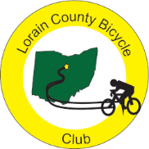
May 2023 Newsletter

April ended with the annual LCBC AFROST ride. Rain, wind, and chill moved in for the day leaving club riders at home on their trainers. Four non-club riders did show up and three of them opted to ride the 51-mile route. One of those riders left early and I escorted the other two out of Amherst before cycling back to the start. Karen, Terry, Clyde, Nancy, Tim, and I were at the start to record attendees and riders. The rain moved through by 10:30 so, hopefully, those on the road dried out and enjoyed the route. Others may have started late once the rain cleared as well. If we want to continue to offer invitational rides, we may want to consider finding several club members who are willing to ride the route even in bad weather to accompany any invitees who ride. Now it’s time to get our legs ready for the JJJ.

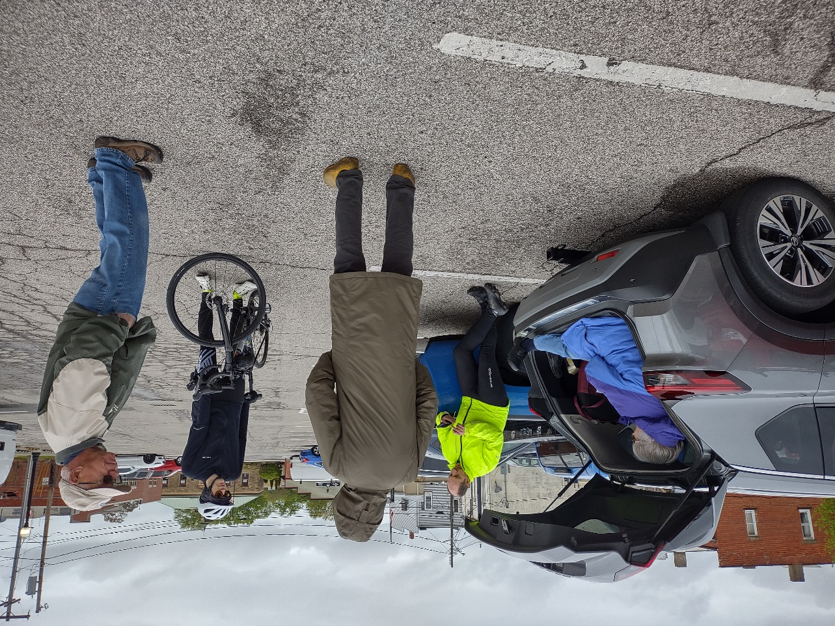

As I led the two riders out of Amherst, I was recalling my first century ride. A friend and I signed up for the Wright Ride in Dayton. The day was much like our AFROST with rain and temperatures in the low 40s. I was riding a Murray bicycle and my friend was riding a Huffy, not exactly state of the art road bikes. This was 44 years ago and we were young enough and stupid enough to complete the ride – two of seven to do so. As I thought about the ride, I came to two conclusions. One, age makes a difference and, two, having a riding partner can make even the most miserable day weatherwise enjoyable. So I encourage each club member to link up with another member to plan and ride at least one stupid, unpleasant ride this season. When you complete it, let me know and I will give you kudos in the newsletter.

Karla is back with a new President’s Corner

I enjoyed the banquet last week. I wish we could have had more folks come out for it. But I guess that’s the way it goes. Paul did a great job with the food and drink ticket system. He may have a job for life.
The low turnout at the banquet got me thinking about the LCBC and its long-term status as a small club. We have had members try to increase our membership with some success, but it always stays fairly small. I believe we need to embrace that aspect of the LCBC. Not that we shouldn’t recruit; of course we should. But we need to behave as a small club, especially on the road. That is the subject of my missive this month. We aren’t big enough to have a “B” group for most rides. Spring is especially difficult since we have a mix of riders who have been on the road all winter and those who are just starting the riding season. We also have riders coming back from surgeries and injuries. What seems to work best for LCBC is a rather organic splitting of the club at the start of each ride. Someone will declare they are going to be slow or going short. What I hope to see is that we can count on there being at least one person who will accompany the person and, someone who will assist a rider who might be lagging behind after the ride begins. The club has been pretty good about waiting at corners, especially on the way out. I know how it feels to be the slow one and it feels terrible when I cause the whole club to go my pace. So, personally, I like the idea of keeping together as best as possible until the half-way stop. Then the spunky riders should be free to fly home. That said, there should also be more than a single rider taking the slower or shorter route home. I know it won’t always work out. Sometimes I feel quite content to drag my butt home by myself if I have run out of gas. But I try to text the ride captain when I finish the ride, just so they know I am safe. As a small club, let’s do our best to be inclusive on the ride, wait at corners on the way out, and enjoy each other’s company. –Karla
As we look to May, Clyde has been surveying club members about the Tuesday and Thursday start times. Traditionally, we move to a 9 A.M. start in May and from the responses he has received so far, this seems to be the members’ choice for this year as well. I do think that, as we get into summer and warm temperatures, we may want to consider some evening rides so those who can’t make the 9 A.M. starts can still ride with the club.
 | May 2023
Sun | Mon | Tue | Wed | Thu | Fri | Sat
30 | May 1 | 2 | 3 | 4 | 5 | 6
9 am  event: AFROST 28/52/61 miles. Start at parking lot #3, 259 Tenney Avenue, Amherst, OH |  | 9 am  30 miles. Start at Oberlin Gasholder Building, 291 South Main Street, Oberlin, OH 44074 |  | 9 am  30 miles. Start at Oberlin Gasholder Building, 291 South Main Street, Oberlin, OH 44074 |  | 9 am  U-show 32 miles. Start at Oberlin Gasholder Building, 291 South Main Street, Oberlin, OH 44074
7 | 8 | 9 | 10 | 11 | 12 | 13
9 am  U-show 32 miles. Start at Oberlin Gasholder Building, 291 South Main Street, Oberlin, OH 44074 |  | 9 am  30 miles. Start at Oberlin Gasholder Building, 291 South Main Street, Oberlin, OH 44074 |  | 9 am  30 miles. Start at Oberlin Gasholder Building, 291 South Main Street, Oberlin, OH 44074 |  | 9 am  U-show 32 miles. Start at Oberlin Gasholder Building, 291 South Main Street, Oberlin, OH 44074
14 | 15 | 16 | 17 | 18 | 19 | 20
9 am  U-show 32 miles. Start at Oberlin Gasholder Building, 291 South Main Street, Oberlin, OH 44074 |  | 9 am  30 miles. Start at Oberlin Gasholder Building, 291 South Main Street, Oberlin, OH 44074 |  | 9 am  30 miles. Start at Oberlin Gasholder Building, 291 South Main Street, Oberlin, OH 44074 |  | 9 am  U-show 32 miles. Start at Oberlin Gasholder Building, 291 South Main Street, Oberlin, OH 44074
21 | 22 | 23 | 24 | 25 | 26 | 27
9 am  U-show 32 miles. Start at Oberlin Gasholder Building, 291 South Main Street, Oberlin, OH 44074 |  | 9 am  30 miles. Start at Oberlin Gasholder Building, 291 South Main Street, Oberlin, OH 44074 |  | 9 am  30 miles. Start at Oberlin Gasholder Building, 291 South Main Street, Oberlin, OH 44074 |  | 8 am  event: Jerry's Jeromesville Journey (JJJ) century. Start at Oberlin Gasholder building, 291 South Main Street, Oberlin, OH
28 | 29  Memorial Day | 30 | 31 | June 1 | 2 | 3
9 am  U-show 32 miles. Start at Oberlin Gasholder Building, 291 South Main Street, Oberlin, OH 44074 |  | 9 am  30 miles. Start at Oberlin Gasholder Building, 291 South Main Street, Oberlin, OH 44074 |  | 9 am  30 miles. Start at Oberlin Gasholder Building, 291 South Main Street, Oberlin, OH 44074 |  | 9 am  U-show 32 miles. Start at Oberlin Gasholder Building, 291 South Main Street, Oberlin, OH 44074

rides@loraincountybicycleclub.org - www.loraincountybicycleclub.org

