LCBC – Lorain County Bicycle Club 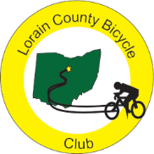 Note: Sunday Rides begin at 8:30 in June
June 2023 Newsletter

May ended with a beautiful day for the club’s JJJ ride. In all, thirty riders rode all or part of the JJJ course. Twelve were club members and the rest were guests. Among the club members, Carla, Wendy, Denny, and Steve did the 53 mile route; Nancy, Paul, and John did a modified half-century loop; Clyde, Ralph, and Terry did the regular Saturday ride to Sterks; Tim did a lot of the century route; and Bill did the 102 mile route but cut off 6 miles coming back from New London on the most direct route. Barron, a former member, did a modified JJJ century. Of the guests, three riders from the Huron area did the JJJ century route with most of the other guests doing the 53 mile loop. Karla also rode on Memorial day finishing 6th on the “Anger Management” 5 hill ride. Shane is riding and hiking in Ireland and on one five mile hike he climbed 2,724 feet. Now, that is a steep hill! Next time he should bike it.

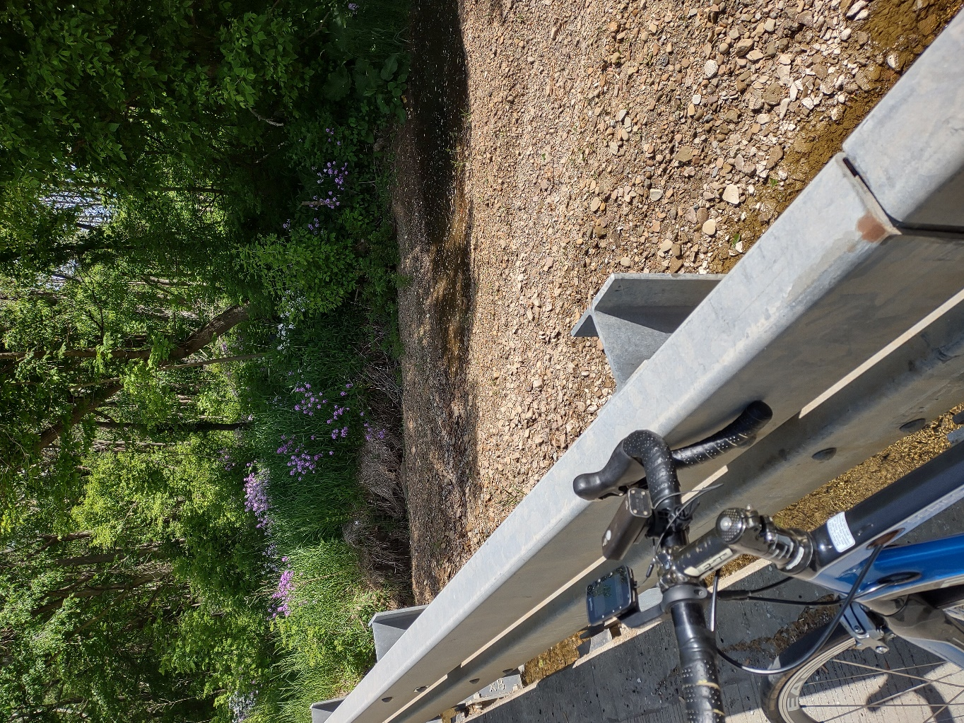
Along the JJJ century route
As we begin June, most of the riders are out getting in miles. Almost every sidelined rider is getting back in the grove with only David still waiting to be able to resume riding.

President’s corner

We had a lovely day for the JJJ and a fairly good turnout. We enjoyed the 53-mile route very much. I write this on Memorial Day, the official start of summer. Denny and I have a busy cycling summer planned. We will be riding in Maine in June ending with the Bangor Hincapie event on the 24th. The roads around Bangor are up and down. So if you see me on Strava and it took me an hour to ride 10 miles, you will know why. Then in July we are off to France to ride Mont Ventoux and Alp D’Huez. We are very excited to repeat these mountains and see if we still can do it. Last time we were a lot younger. Wish us luck. Find your cycling adventure this summer. Getting out on roads that are NOT within 50 miles of Oberlin is really worth it. Smile.

With Karla’s challenge to “Find your cycling adventure …,” here are a couple of the myriad of cycling opportunities this summer. On June 24th, Knox County is holding “Trail Apalooza” from 9 A.M. to 2 P.M. with food trucks and a chance to cycle around Brinkhaven, Danville, Gambier, Mount Vernon, and Centerburg along the bike trails in those areas (thanks to Louise for sharing this one). This will not be a fast ride as walkers share the trail but it would be a fun outing. Another option is to take the Lorain Metro Parks’ challenge. Hike, bike, or run 200 miles within the Lorain County Metro Parks from April 1,2023-April 1,2024 Submit a completed tracking log to the Carlisle Visitor Center (12882 Diagonal Rd., LaGrange 44050) by April 1, 2024, and pick up your commemorative metal badge Encourage others to participate and share snapshots of your journey on social media with the hashtag #LorainCounty200 (thanks to Nancy for sharing this option). A third option is the June 17th, 20th Annual Peckerhead Invitational Bike Ride and Weenie Roast. This ride has routes of 35, 55, and 75 miles ranging from somewhat easy to pretty darn hilly. https://www.bikeride.com/events/20th-annual-peckerhead-invitational-bike-ride-and-weenie-roast/ The ride starts at 536 Chevy Chase Road, 44907, Mansfield, Ohio 20th Annual Peckerhead Invitational Bike Ride and Weenie Roast | BikeRide

Between family trips and other obligation, we will all be on and off the bike and riding with the club during these summer months. I hope to see and ride with all of you as often as possible during this peak riding season.

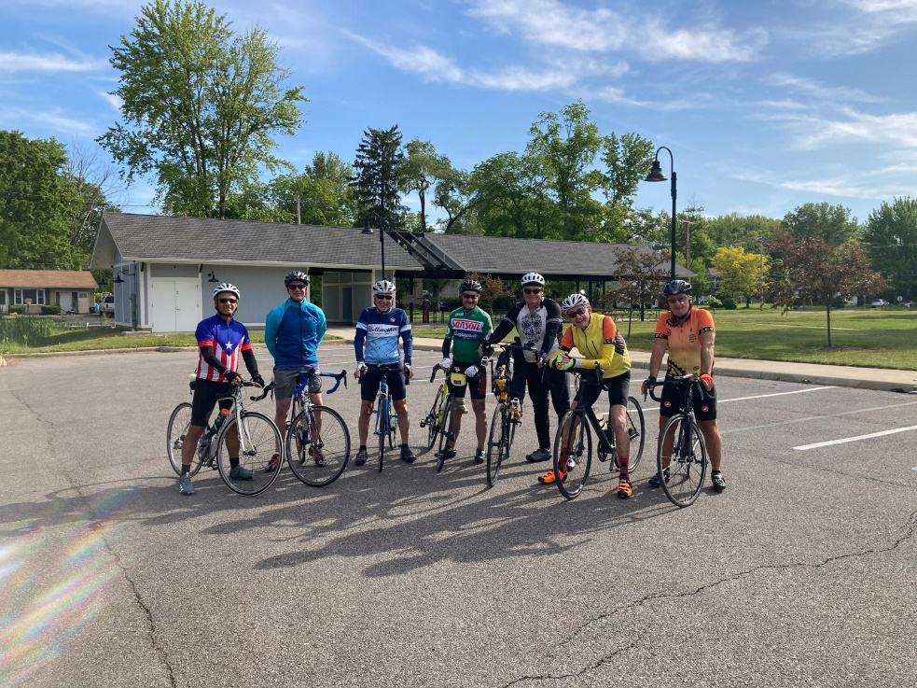
Two new riders on the final Sunday ride in May (Photo by Nancy)
Lorain County Bicycle Club

 | June 2023
Sun | Mon | Tue | Wed | Thu | Fri | Sat
 |  |  |  | 1 | 2 | 3
 |  |  |  | 9 am  30 miles. Start at Oberlin Gasholder Building, 291 South Main Street, Oberlin, OH 44074 |  | 9 am  30 miles. Start at Oberlin Gasholder Building, 291 South Main Street, Oberlin, OH 44074
4 | 5 | 6 | 7 | 8 | 91 | 10
8:30 am  Watch for Clyde’s email, Gasholder Building, 291 South Main Street, Oberlin, OH 44074 |  | 9 am  30 miles. Start at Oberlin Gasholder Building, 291 South Main Street, Oberlin, OH 44074 |  | 9 am  30 miles. Start at Oberlin Gasholder Building, 291 South Main Street, Oberlin, OH 44074 |  | 9 am  U-show 32 miles. Start at Oberlin Gasholder Building, 291 South Main Street, Oberlin, OH 44074
11 | 12 | 13 | 14 | 15 | 16 | 17
8:30 am  Watch for Clyde’s email. Oberlin Gasholder Building, 291 South Main Street, Oberlin, OH 44074 |  | 9 am  30 miles. Start at Oberlin Gasholder Building, 291 South Main Street, Oberlin, OH 44074 |  | 9 am  30 miles. Start at Oberlin Gasholder Building, 291 South Main Street, Oberlin, OH 44074 |  | 9 am  U-show 32 miles. Start at Oberlin Gasholder Building, 291 South Main Street, Oberlin, OH 44074
18 | 19 | 20 | 21 | 22 | 23 | 24
8:30 am  Watch for Clyde’s email. Oberlin Gasholder Building, 291 South Main Street, Oberlin, OH 44074 |  | 9 am  30 miles. Start at Oberlin Gasholder Building, 291 South Main Street, Oberlin, OH 44074 |  | 9 am  30 miles. Start at Oberlin Gasholder Building, 291 South Main Street, Oberlin, OH 44074 |  | 9 am  U-show 32 miles. Start at Oberlin Gasholder Building, 291 South Main Street, Oberlin, OH 44074
25 | 26 | 27 | 28 | 29 | 30 | July 1
8:30 am  Watch for Clyde’s email. Oberlin Gasholder Building, 291 South Main Street, Oberlin, OH 44074 |  | 9 am  30 miles. Start at Oberlin Gasholder Building, 291 South Main Street, Oberlin, OH 44074 |  | 9 am  30 miles. Start at Oberlin Gasholder Building, 291 South Main Street, Oberlin, OH 44074 |  | 9 am  U-show 32 miles. Start at Oberlin Gasholder Building, 291 South Main Street, Oberlin, OH 44074

rides@loraincountybicycleclub.org - www.loraincountybicycleclub.org

