LCBC – Lorain County Bicycle Club 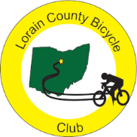
February 2024 Newsletter

The club was faced with the mood swings of January. A ride was held on January 2nd but, per Clyde, there were no more outdoor rides until January 27 when a few riders rode a 28 mile Wakeman loop. Shane got a short Chicago ride in and Paul has been racking up the miles in and around the Villages in Florida. Let’s hope that February is kinder to Northeast Ohio.

I have been out riding almost every day in Key West even though it is a different type of riding. Most rides involve some picking up of supplies and all rides begin and end on busy roads and paths. I have my touring bike down here which, though quite heavy, allows me to run errands. The temperatures are warm but the winds have been considerable. There was only one day when the winds were calm. A typical day has a base wind of 20 mph with gusts. On one ride pushed the gusts over 40 so I avoided riding over “the byte” which resembles the Parson’s bridge over Rt. 20.

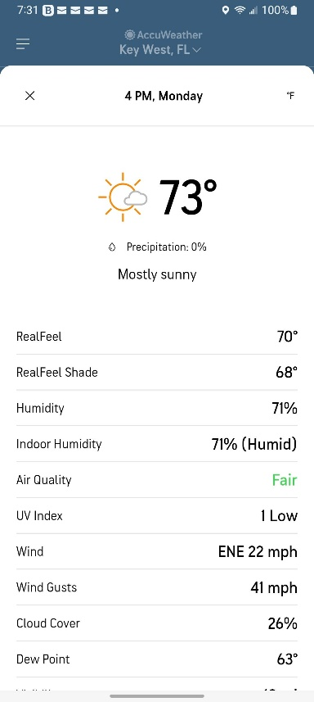

As of this writing, the LCBC club meeting has been rescheduled for February 6th at the Amherst Library. Watch for emails about this important meeting. Good luck to all the candidates and best wishes to Denny for a complete recovery by then.

President's corner

Hello everyone. Thanks for your understanding last week when I had to cancel the meeting. Denny is home and doing much better. Thanks for all of your good wishes. Karen and I would like to hold the meeting on Tuesday February 6th. 6:30 at the Amherst Library.
We all are enduring more indoor riding and hoping the roads dry up soon.

Karla

Lorain County Bicycle Club

 | February 2024
Sun | Mon | Tue | Wed | Thu | Fri | Sat
28 | 29 | 30 | 31 | February 1 | 2 | 3
9 am  U-show 32 miles. Start at Oberlin Gasholder Building, 291 South Main Street, Oberlin, OH 44074 |  | 11 am  30 miles. Start at Oberlin Gasholder Building, 291 South Main Street, Oberlin, OH 44074 |  | 11 am  30 miles. Start at Oberlin Gasholder Building, 291 South Main Street, Oberlin, OH 44074 |  | 9 am  U-show 32 miles. Start at Oberlin Gasholder Building, 291 South Main Street, Oberlin, OH 44074
4 | 5 | 6 | 7 | 8 | 9 | 10
9 am  U-show 32 miles. Start at Oberlin Gasholder Building, 291 South Main Street, Oberlin, OH 44074 |  | 11 am  30 miles. Start at Oberlin Gasholder Building, 291 South Main Street, Oberlin, OH 44074 |  | 11 am  30 miles. Start at Oberlin Gasholder Building, 291 South Main Street, Oberlin, OH 44074 |  | 9 am  U-show 32 miles. Start at Oberlin Gasholder Building, 291 South Main Street, Oberlin, OH 44074
11 | 12 | 13 | 14 | 15 | 16 | 17
9 am  U-show 32 miles. Start at Oberlin Gasholder Building, 291 South Main Street, Oberlin, OH 44074 |  | 11 am  30 miles. Start at Oberlin Gasholder Building, 291 South Main Street, Oberlin, OH 44074 |  | 11 am  30 miles. Start at Oberlin Gasholder Building, 291 South Main Street, Oberlin, OH 44074 |  | 9 am  U-show 32 miles. Start at Oberlin Gasholder Building, 291 South Main Street, Oberlin, OH 44074
18 | 19  Presidents' Day | 20 | 21 | 22 | 23 | 24
9 am  U-show 32 miles. Start at Oberlin Gasholder Building, 291 South Main Street, Oberlin, OH 44074 |  | 11 am  30 miles. Start at Oberlin Gasholder Building, 291 South Main Street, Oberlin, OH 44074 |  | 11 am  30 miles. Start at Oberlin Gasholder Building, 291 South Main Street, Oberlin, OH 44074 |  | 9 am  U-show 32 miles. Start at Oberlin Gasholder Building, 291 South Main Street, Oberlin, OH 44074
25 | 26 | 27 | 28 | 29 | March 1 | 2
9 am  U-show 32 miles. Start at Oberlin Gasholder Building, 291 South Main Street, Oberlin, OH 44074 |  | 11 am  30 miles. Start at Oberlin Gasholder Building, 291 South Main Street, Oberlin, OH 44074 |  | 11 am  30 miles. Start at Oberlin Gasholder Building, 291 South Main Street, Oberlin, OH 44074 |  | 9 am  U-show 32 miles. Start at Oberlin Gasholder Building, 291 South Main Street, Oberlin, OH 44074

rides@loraincountybicycleclub.org - www.loraincountybicycleclub.org

