LCBC – Lorain County Bicycle Club 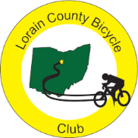
August 2023 Newsletter

July turned out to be a great cycling month with the Lorain County weather allowing all but one club rides. Seventeen of the eighteen scheduled rides took place.

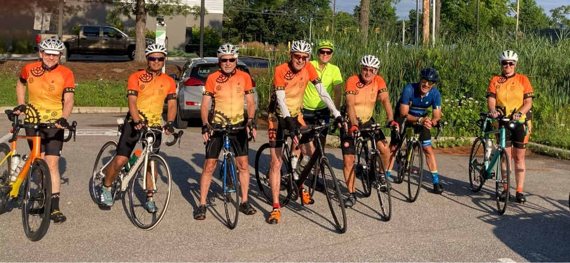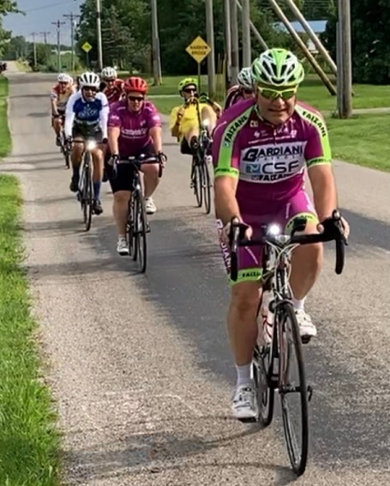
Last Sunday in July ride (photo by Terry) Saturday in July ride (photo by Nancy)

President, Karla Hubbard, and, Past-President, Denny Hubbard went with members Wendy and Steve to France to ride sections of this year’s Tour de France. If you use Strava, you may have seen Karla’s post on riding Alpe d’Huez. She deserves the grit and determination award for riding 11.36 super steep miles up to the summit in 3 hours and 7 minutes. Kudos! Terry two went to Indiana for a three day Amish Lands and Lakes Bicycle Tour to finish the month.

Karla sent some pictures along with a short greeting.

“We are having a great time in the shadows of Ventoux. The photo of the dead man on col de l’Homme is one of the shots (guess which). Then Steve, Wendy, and us on top of Ventoux. Also some other shots (Denny heading up Ventoux, my selfie somewhere in the zone of pain, and a shot of the peak). Enjoy the flatlands!”
Karla & Denny

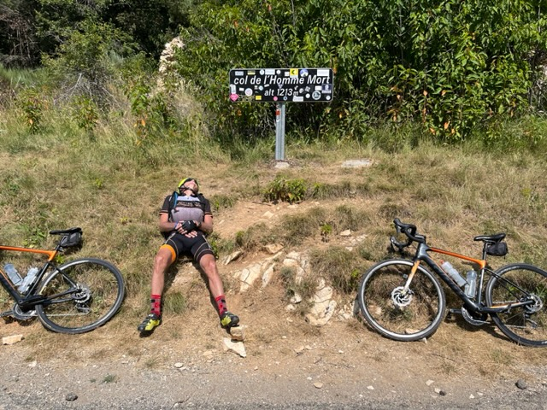
Just like the tour riders, Denny has time for his afternoon nap.
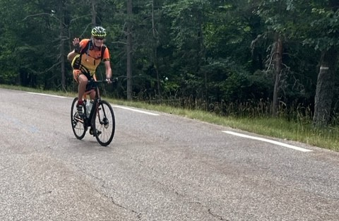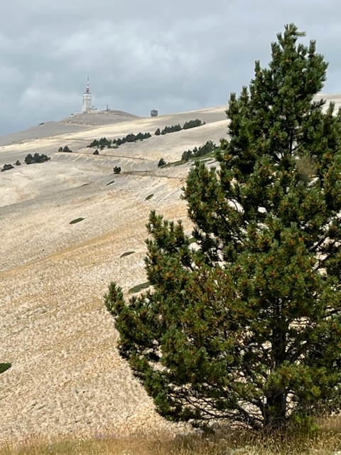
Denny heading up Ventoux Ventoux peak above the tree line

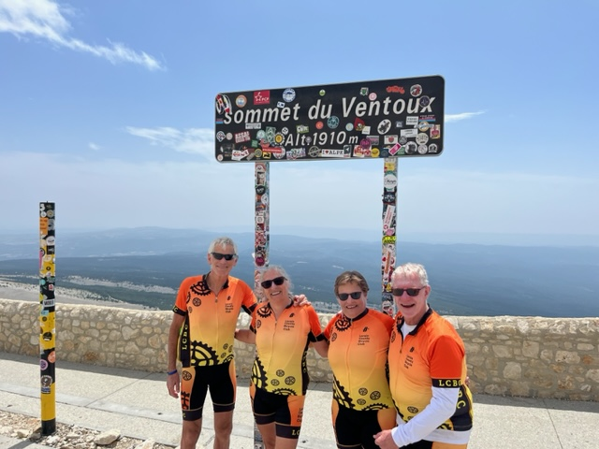
Denny, Karla, Wendy and Steve at the Summit of Ventoux
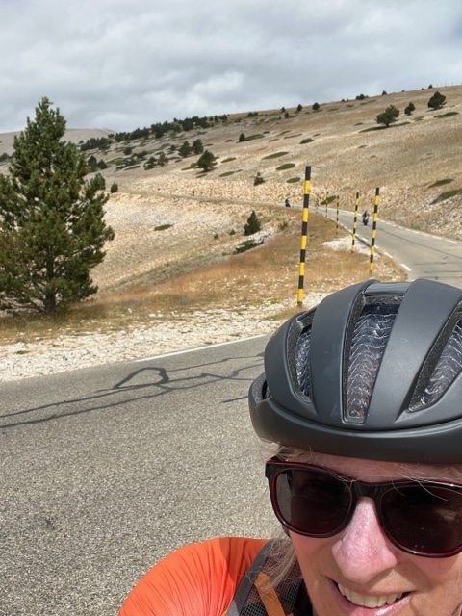
Karla grinding up the mountain

As summer peaks, the time has come to begin thinking about November’s Red Flannel ride. As chair of the event, Karen Hobbs wants to share the following:
It’s coming, along with cooler weather!
Have you put November 5th on your calendar?
That’s when the club needs everyone to work (volunteer) the RED FLANNEL, dawn to about 3pm.
Well, not everyone will work at dawn!

The flyers have been ordered and I am working on EVENTBRITE registration web-site submission.

For the new members, the work that goes into putting on the ride takes the whole club; from getting the route painted to making chili, cookies, or both!

More details next month.

This is the LCBC’s only fund-raising event for the year.

Karen Hobbs, Red Flannel Coordinator

August brings surgery for Terry H. and, hopefully, the return for David. Our third invitational ride, “Roast Your Buns” is scheduled for the first Sunday in August (the 6th). Let Karla or Karen know if you want to help sign riders in. There is no sag and no club stops for this unsupported ride. The current forecast is for a warm but dry day which would be perfect. As usual, there are three routes – 28, 52, and 70 miles. Invite your friends and rivals to make this a fun and well attended ride. The website suggests an 8 A.M. start.

Lorain County Bicycle Club

 | August 2023
Sun | Mon | Tue | Wed | Thu | Fri | Sat
30 | 31 | August 1 | 2 | 3 | 4 | 5
8:30 am  Oberlin Vermilion 47 miles. Start at Oberlin Gasholder Building, 291 South Main Street, Oberlin, OH 44074 |  | 9 am  30 miles. Start at Oberlin Gasholder Building, 291 South Main Street, Oberlin, OH 44074 |  | 9 am  30 miles. Start at Oberlin Gasholder Building, 291 South Main Street, Oberlin, OH 44074 |  | 9 am  U-show 32 miles. Start at Oberlin Gasholder Building, 291 South Main Street, Oberlin, OH 44074
6 | 7 | 8 | 9 | 10 | 11 | 12
8 am  event: Roast Your Buns. 28,52, or 70 miles. Start at Oberlin Gasholder building, 291 South Main Street, Oberlin, OH |  | 9 am  30 miles. Start at Oberlin Gasholder Building, 291 South Main Street, Oberlin, OH 44074 |  | 9 am  30 miles. Start at Oberlin Gasholder Building, 291 South Main Street, Oberlin, OH 44074 |  | 9 am  U-show 32 miles. Start at Oberlin Gasholder Building, 291 South Main Street, Oberlin, OH 44074
13 | 14 | 15 | 16 | 17 | 18 | 19
8:30 am  U-show 32 miles. Start at Oberlin Gasholder Building, 291 South Main Street, Oberlin, OH 44074 |  | 9 am  30 miles. Start at Oberlin Gasholder Building, 291 South Main Street, Oberlin, OH 44074 |  | 9 am  30 miles. Start at Oberlin Gasholder Building, 291 South Main Street, Oberlin, OH 44074 |  | 9 am  U-show 32 miles. Start at Oberlin Gasholder Building, 291 South Main Street, Oberlin, OH 44074
20 | 21 | 22 | 23 | 24 | 25 | 26
8:30 am  U-show 32 miles. Start at Oberlin Gasholder Building, 291 South Main Street, Oberlin, OH 44074 |  | 9 am  30 miles. Start at Oberlin Gasholder Building, 291 South Main Street, Oberlin, OH 44074 |  | 9 am  30 miles. Start at Oberlin Gasholder Building, 291 South Main Street, Oberlin, OH 44074 |  | 9 am  U-show 32 miles. Start at Oberlin Gasholder Building, 291 South Main Street, Oberlin, OH 44074
27 | 28 | 29 | 30 | 31 | September 1 | 2
8:30 am  U-show 32 miles. Start at Oberlin Gasholder Building, 291 South Main Street, Oberlin, OH 44074 |  | 9 am  30 miles. Start at Oberlin Gasholder Building, 291 South Main Street, Oberlin, OH 44074 |  | 9 am  30 miles. Start at Oberlin Gasholder Building, 291 South Main Street, Oberlin, OH 44074 |  | 9 am  U-show 32 miles. Start at Oberlin Gasholder Building, 291 South Main Street, Oberlin, OH 44074

rides@loraincountybicycleclub.org - www.loraincountybicycleclub.org

